**Fractional Knapsack**

**Problem**

We are given n items with {weight, value} of each item and the capacity of knapsack (bori) W. We need to put these items in the knapsack such that the final value of items in the knapsack is maximum.

**Example**

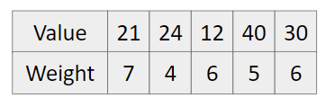

W = 20

**Approach (Think greedily)**

1. Calculate value per unit weight.

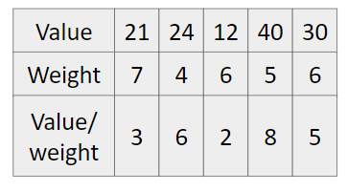

1. Sort in decreasing order according to value/weight.

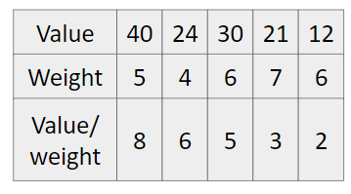

1. Pick from the starting till our knapsack has capacity.

So maximum value = 40 + 24 + 30 + 3(5) = 109.

**Code**

#include<bits/stdc++.h>

using namespace std;

#define int long long

struct item {

double value, weight, valuePerWeight;

};

bool compare(item i1, item i2) {

return i1.valuePerWeight > i2.valuePerWeight;

}

signed main() {

int n; cin >> n;

vector<item> items;

for(int i=0; i<n; i++) {

double v,w;

cin >> v >> w;

items.push_back({v,w,v/w});

}

double W; cin >> W;

sort(items.begin(), items.end(), compare);

int ans = 0;

for(int i=0; i<n; i++) {

if(W >= items[i].weight) {

W -= items[i].weight;

ans += items[i].value;

}

else {

ans += W * items[i].valuePerWeight;

W = 0;

break;

}

}

cout << ans << endl;

return 0;

}